Text Book Login Instructions
https://www-k6.thinkcentral.com/ePC/start.do
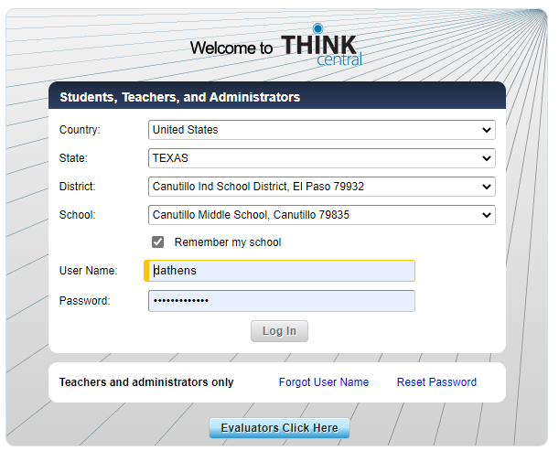
Once you see this page you will use the drop downs to go to the appropriate fields
Your user name and password will be provided to you via e-mail. They are different than your school account.
Once in you will see options (icons) that look like this.
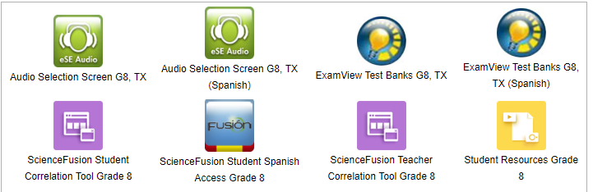

You can now choose the txt book audio, text in English or Spanish. You will also have assignment options if your teacher assigned them to you.

